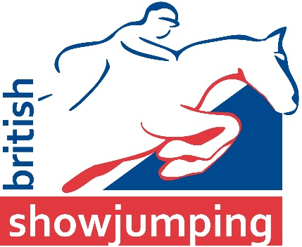

HERTFORDSHIRE & GREATER LONDON (39A)
AREA ELECTIONS

Name of Applicant: | Membership No. of Applicant:
Proposer: | Seconder:
Name:  (please print) | Name:  (please print)
Signature: | Signature:
Address: | Address:
Membership No: | Membership No:

I agree that I am willing to serve on the Hertfordshire & Greater London Area Committee if elected

Signature......................................................................................................................................

Name (please print) ......................................................................................................................

Address..................................................................................................................………………..

............................................................................................Membership No....................................

Please return application to:

Nicky McMurdo
British Showjumping
Meriden Business Park
Meriden
West Midlands
CV5 9RG

Email: nicky.mcmurdo@britishshowjumping.co.uk

Applications close: Midday – Friday, 3rd February 2017

